Breadth First Search

Approach:
- For Graph as well we will use the Queue for performing the BFS.
- We will use the boolean[] to keep a track of the nodes because unlike tree during traversal we might keep moving into the circles by visiting same nodes repeatedly.
- In our example we are using adjacency List for the Graph Representation.

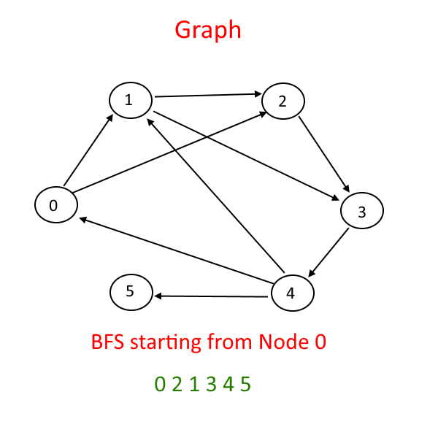
Breadth-First Search (Traversal) in a Graph is quite similar to Binary Tree.

…………………………………………………………………………………………………..

import java.util.LinkedList;
import java.util.Queue;
public class GraphBFS {
public static void main(String args[]) {
Graph g = new Graph(6);
g.addEdge(0, 1);
g.addEdge(0, 2);
g.addEdge(1, 2);
g.addEdge(1, 3);
g.addEdge(3, 4);
g.addEdge(2, 3);
g.addEdge(4, 0);
g.addEdge(4, 1);
g.addEdge(4, 5);
g.BFS(0);

}
}

class Node {
int dest;
Node next;
public Node(int d) {
dest = d;
next = null;
}
}

class adjList {
Node head;
}
class Graph {
int V;
adjList[] array;
public Graph(int V) {
this.V = V;
array = new adjList[V]; // linked lists = number of Nodes in Graph

for (int i = 0; i < V; i++) {
array[i] = new adjList();
array[i].head = null;
}
}
public void addEdge(int src, int dest) {
Node n = new Node(dest);
n.next = array[src].head;
array[src].head = n;
}
public void BFS(int startVertex) {
boolean[] visited = new boolean[V];
Queue<Integer> s = new LinkedList<Integer>();
s.add(startVertex);
while (s.isEmpty() == false) {
int n = s.poll();
System.out.print(" " + n);
visited[n] = true;
Node head = array[n].head;
while (head != null) {
if (visited[head.dest] == false) {
s.add(head.dest);
visited[head.dest] = true;
}
head = head.next;
}
}
}
}

